# My Data Journey with Motorcycle Classification

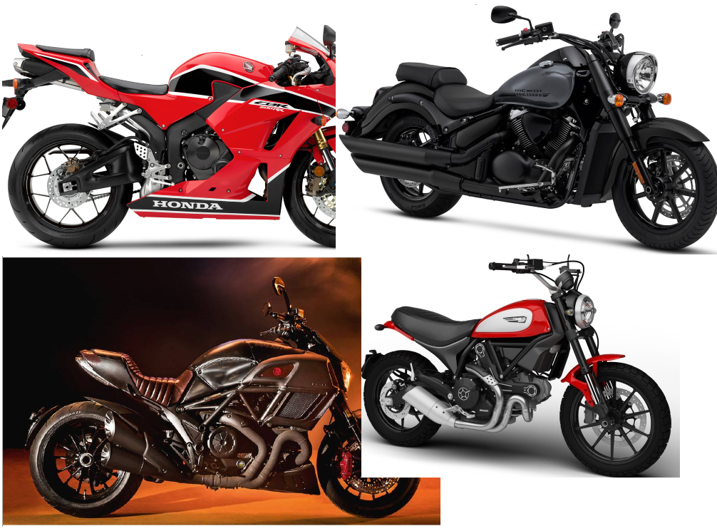

Contents

My Data Journey with Motorcycle Classification 1

Summary 1

Data 2

Obtaining Data 2

Links 2

Pre-processing 4

Links 4

EDA 5

Links 5

Data Tuning 8

Transforms 9

Links 9

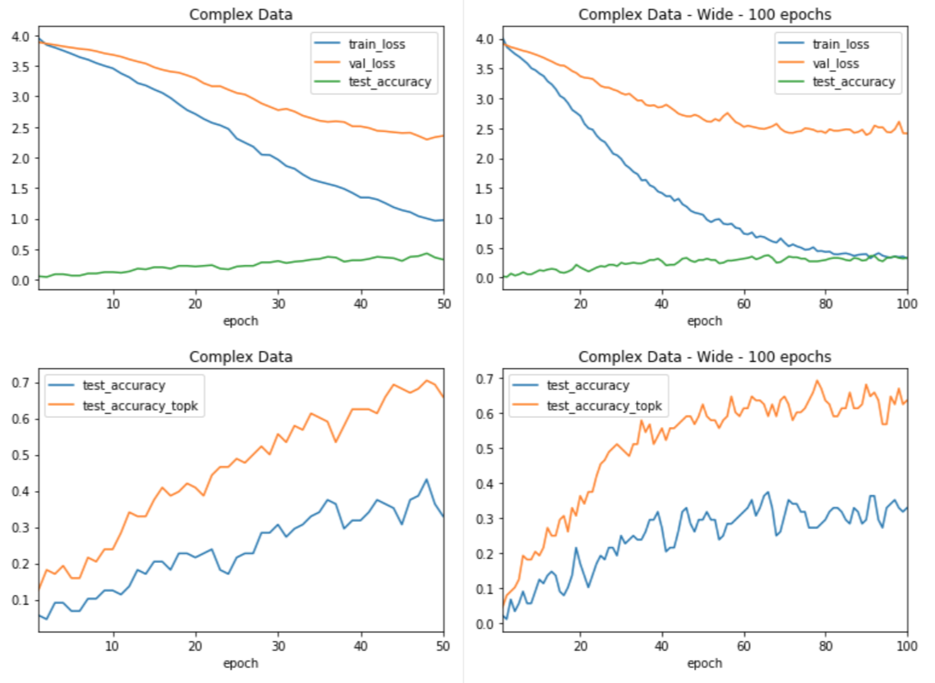 12

Balance 12

Links 12

Modeling 13

Model Selection 14

Resnet 14

Links 14

Generalization 15

Links 15

Model tuning 17

Learning rate 17

Links 17

Batch Size 19

Links 19

Final Model 21

Further Research 22

Conclusion 23

# Summary

It always starts the same way. The forum post is accompanied by a photo of some random motorcycle. What bike is this? Experts and novices alike scramble to find the make, model and year of the motorcycle pictured. Wouldn’t it be nice to easily classify a motorcycle from an image? This project seeks to do just that.

Using the power of pre-trained convolutional neural networks, we can customize the models to classify the year, make and model of motorcycle images. What kind of performance can we expect? Is it even possible? Motorcycles can be very similar between various models and years. We will find that we can routinely achieve around 70% top-3 accuracy with a relatively small data set. We will also find that to increase accuracy, we would likely need to greatly increase the size of the data set collected in this project. Along the way, we will look at methods to collect and process data, while building a suitable model for classification.

In the end, we will find that model tuning, data transformation, and data augmentation have, at best, incremental benefits on the model. In fact, the best time I spent on this project involved performance tuning Pytorch itself to achieve faster modeling times.

Throughout the last eight weeks, I conducted myriad experiments. Not all are included in this document or code repository. Most test results show will test data with fifty targets over fifty epochs. Some will include more epochs as needed. Data with fifty targets was the sweet spot between a low number of targets with high accuracy and a high number of targets with low accuracy.

** Please note. Only selected code examples are included in this document. To see all code, look through the Jupyter notebooks and the two python packages in the git repository. The notebooks are numbered in order needed to run all of them. They have all ben saved with output. This means you can see the code and results in the Github repository.

** Since I do not have license to publish the data I used, data is not included in this repository. Though, the code to obtain data is. See notebooks 1 and 2. Notebook 2 will require a Microsoft Azure account and an API key for their cognitive services. As with any automated image download, issues can occur. The most common was bad images and images with long names. These are easily resolved and script output points to the issues.

** To run the Jupyter notebooks, a little setup is required. Libraries are listed in each of the notebooks. I recommend using Anaconda and creating a virtual environment. Utility functions and classes are included in randomdatautilities and modeling. The can be installed with pip -e.

# Data

I could not find any existing free data sets for image classification. There were commercial options, but prices were not listed. In the end, I decided to create my own data set. After a lot of experimentation, I found that totalmotorcycle.com had a very consistent naming convention for motorcycles and included just about every commercial motorcycle ever made. This was a good start.

## Obtaining Data

### Links

* [Notebook 1](https://github.com/leogodin217/motorcycle_classification/blob/master/code/1%20-%20First%20Motorcycle%20Data.ipynb): All code to obtain the first 700 images with 366 classes.
* [Notebook 2](https://github.com/leogodin217/motorcycle_classification/blob/master/code/2%20-%20Finding%20Motorcycle%20Data.ipynb): Code needed to obtain 2800 images across 366 classes. (Uses randomdatautilities.downloads from this repository).

With help from a Python package called google_image_download, I was able to download about 700 images by searching for specific makes and years. The below results are from a search on “2017 kawasaki”. Notice how we get multiple models and that the naming conventions are pretty consistent. they include the year, make and model, with a few different suffixes. I was able to create a few regular expressions to obtained clean classes for each image. The first images results in a class of “2017 kawasaki ninja 300”. This first data set included 367 classes across 700 images. Not a bad start, but it is unlikely that this small number of images would be sufficient.

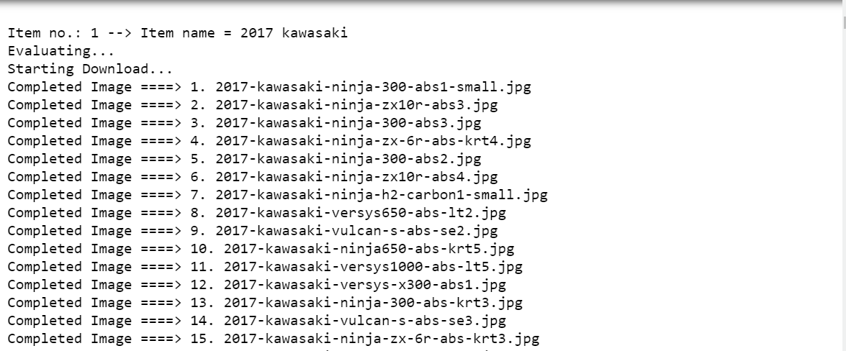

Figure . Image names fro topmotorcycle.com

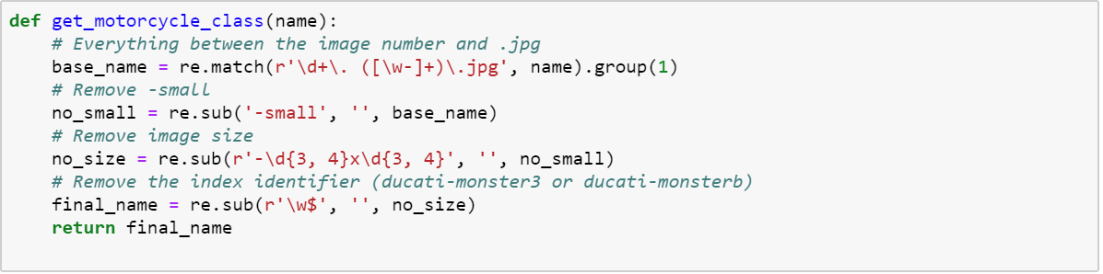

Figure . Regular expressions to extract targets from image names.

While this data set was interesting, it was not big enough. I found that Bing has a great image-search API. Using this API, I was able to download 2800 images across all the classes. Through manual searches, I found that capping the number of images per class to ten provided the best results. Fewer than ten generally provided excellent images. More than ten would often include other motorcycles or random parts from a catalog. After running several tests, I worried about performance.

I did not want to lose a day waiting for images to download. To that end, I learned about parallel processing in Python. I spent about three hours getting everything working, started the downloads and took a shower. When I came back, the downloads had completed. Looking back, I probably cost myself time by spending three hours learning how to use parallel processing. That being said, it is a valuable skill that will certainly be useful in the future. With 2800 motorcycle images downloaded, it was time to take a peak at what I got.

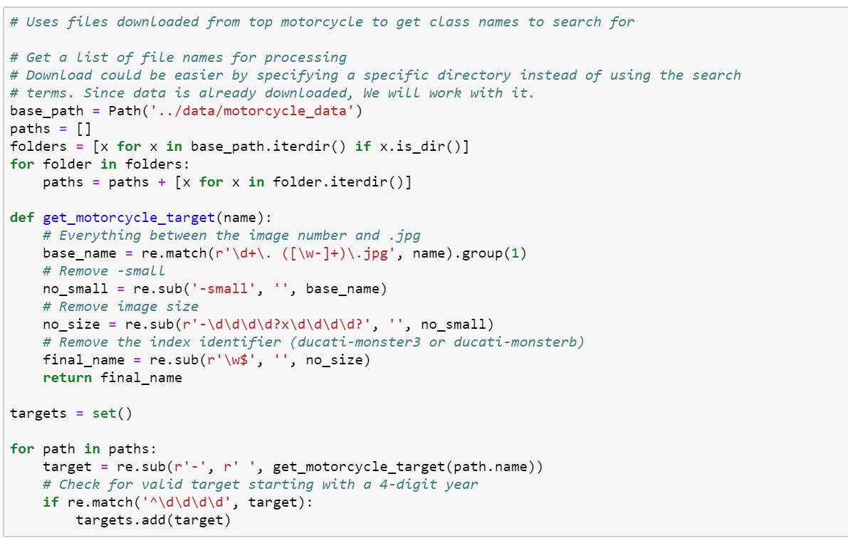

Figure . Code used to turn totalmotorcycle.com images into searchable targets.

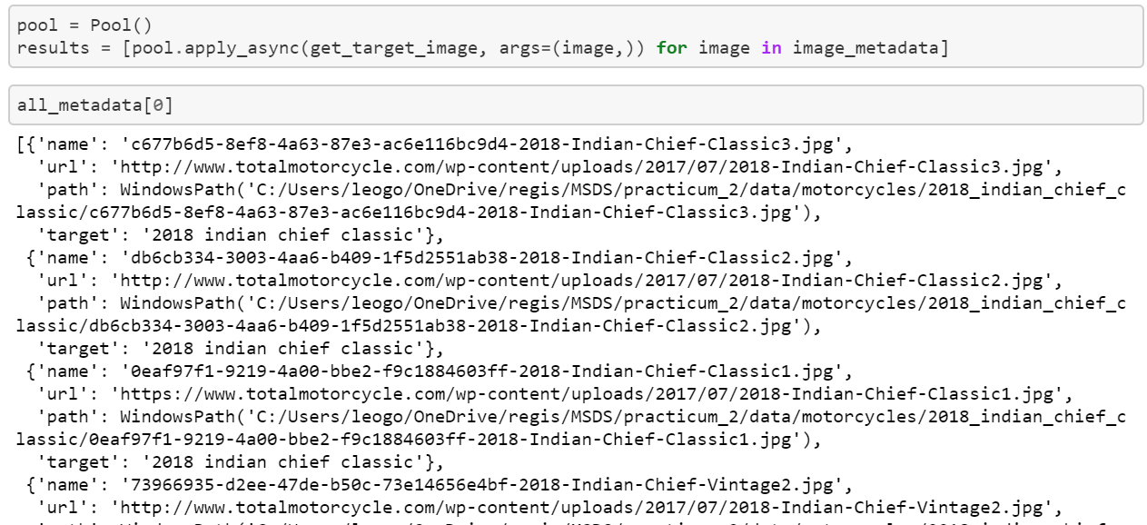

Figure . Code to download images across 16 threads on 8 cores.

## Pre-processing

### Links

* [Notebook 3](https://github.com/leogodin217/motorcycle_classification/blob/master/code/3-%20Data%20pre-processing.ipynb): All code to pre-process the data.

Throughout this process, I often came back to notebook 3. This is where I created clean data sets, that fit various scenarios. First, I ensured there were at least three images per class, so we would have one image for training, validation and testing. Later on, I wanted to see what would happen if I made the images square, by padding the top and bottom. Near the end of the project, I wanted to test classes that had eight or more images, then seven or fewer. These results will appear later under Data Tuning.

The most interesting code from this notebook segments images into train, validation and test. It allows us to easily segment images per class with a proportion dedicated to each. With that done, it was time for some exploratory data analysis.

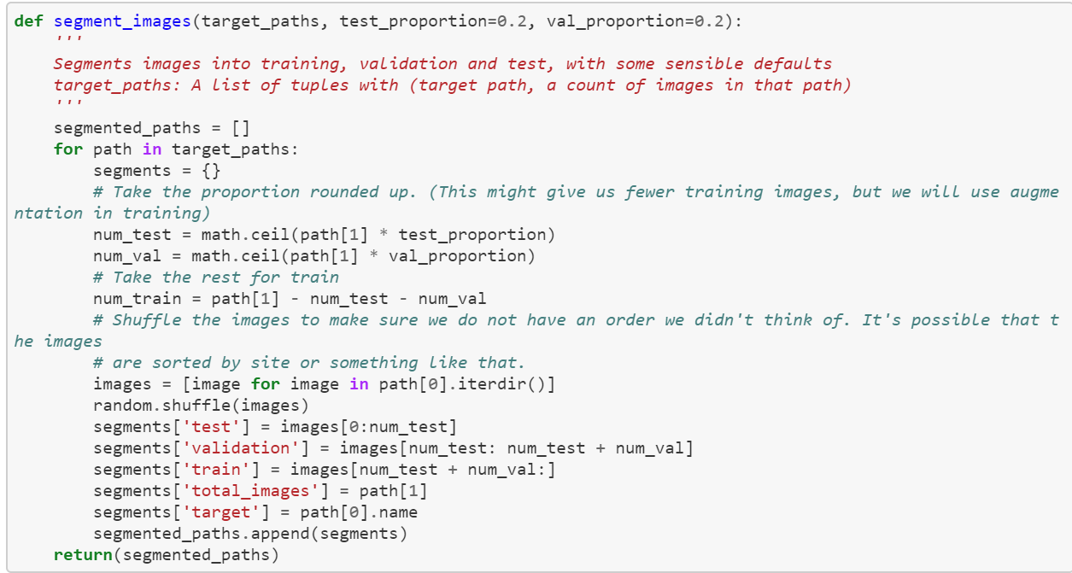

Figure . Segmenting images to train, validation and test.

## EDA

### Links

* [Notebook 4](https://github.com/leogodin217/motorcycle_classification/blob/master/code/4%20-%20Image%20EDA.ipynb): All code to perform EDA.

First up was figuring out how many images we had per class. While it varied greatly, as shown by the first image. The histogram showed that most classes had at least eight images.

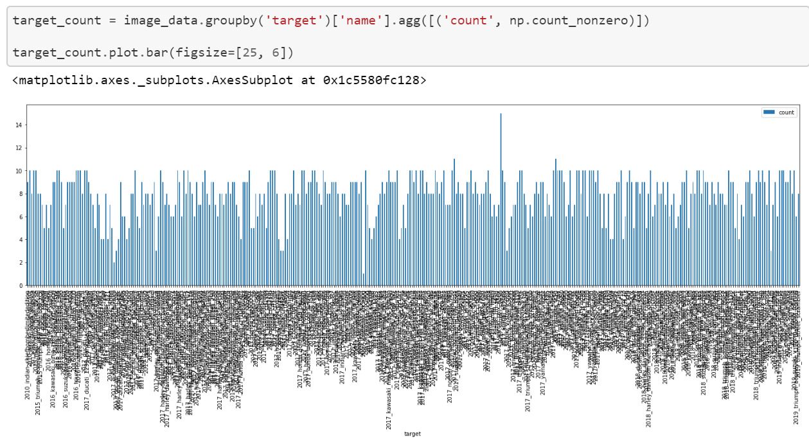

Figure . Images per class.

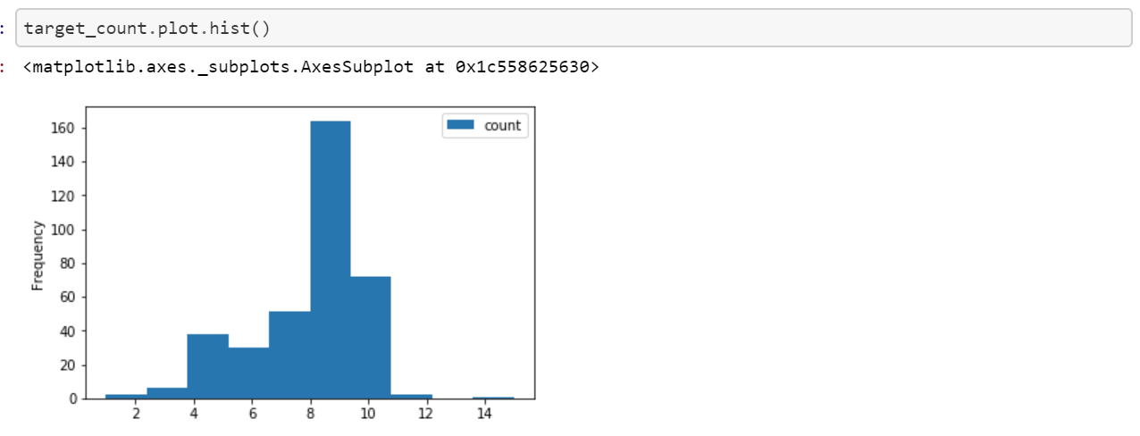

Figure . Histogram of images per class.

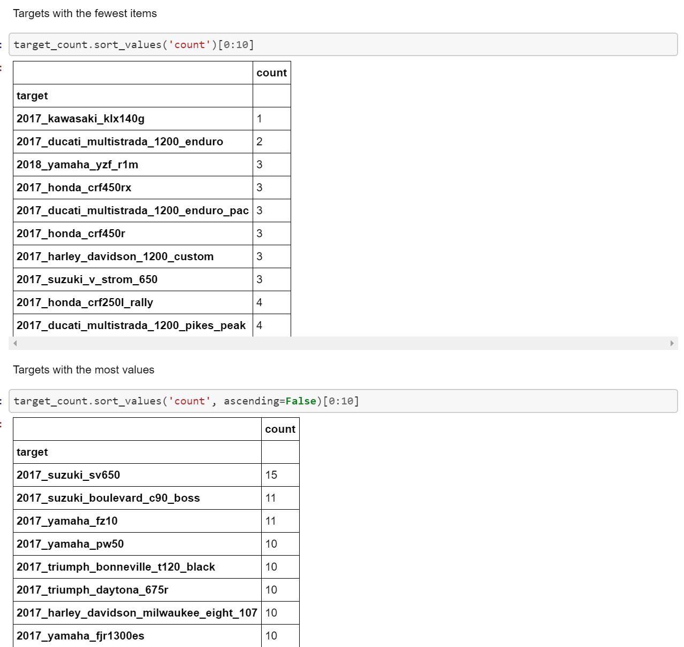

Figure . Classes with the least and most images.

It was easy to display and resize certain images using Python’s PIL library.

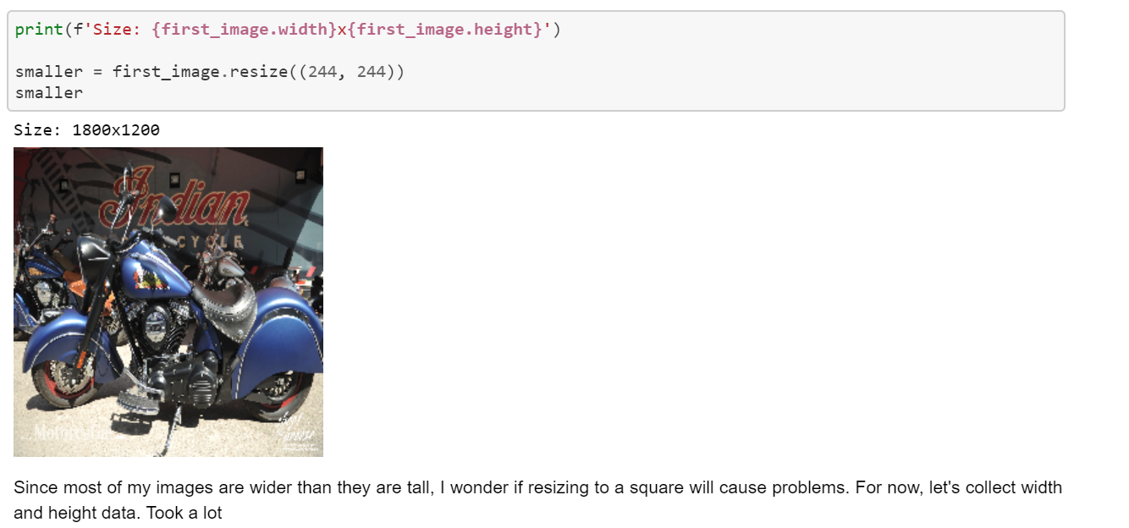

Figure 9. A resized Indian Motorcycle.

# Data Tuning

With a small number of images per class, data transformations are critical to model performance. Also, balancing the data, can have significant impacts. In order to efficiently test various configurations, I created a Python package with constants and functions for creating Pytorch data loaders. One of the more interesting features is the TargetSampler. This allows us to create data loaders that will return training, validation and testing data sets that all have the same classes. It allows us to subset the data, without worrying about any differences in classes.

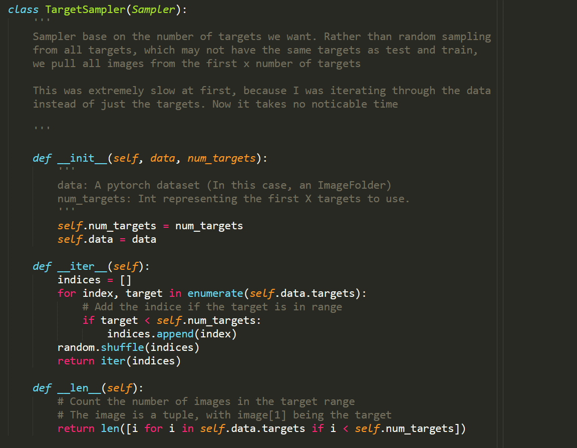

Figure 10. Sampler to ensure subsets have the same classes.

## Transforms

### Links

* [Notebook 5](https://github.com/leogodin217/motorcycle_classification/blob/master/code/5%20-%20Transform%20Selection.ipynb): Code to test various data transforms. (Utilizes modelingfunctions.dataprocessing, modelingfunctions.modeling and modelingfunctions.utilities.)

I tested several different transforms. The most basic was a default transform that simply resized and cropped the images. The more complex transforms included data augmentation by performing random transforms like color jitter and rotation. Data augmentation is common when data is limited. Furthermore, I tried wider, smaller and larger transforms.

While there was no clear winner. The complex transforms, using the default size held the most promise. Even though it did not result in the highest accuracy, it had more room to grow and less difference between training loss and validation loss. Others, that performed slightly better after 50 epochs, saw a logarithmic pattern to accuracy, which suggests they will not gain much from further training. All models showed a strong divergence between training loss and validation loss. This suggests the model may not generalize well.

Note that all complex transforms were only applied to training data. Test and validation data utilized simple transforms.

Images showing results all include a single plot for training and validation loss combined with test accuracy. A second plot shows the test accuracy and top-3 accuracy. Notice how the basic data starts strong but tails off after 35 epochs. The complex transforms vary more but are generally increasing in accuracy. More results are included in notebook 5.

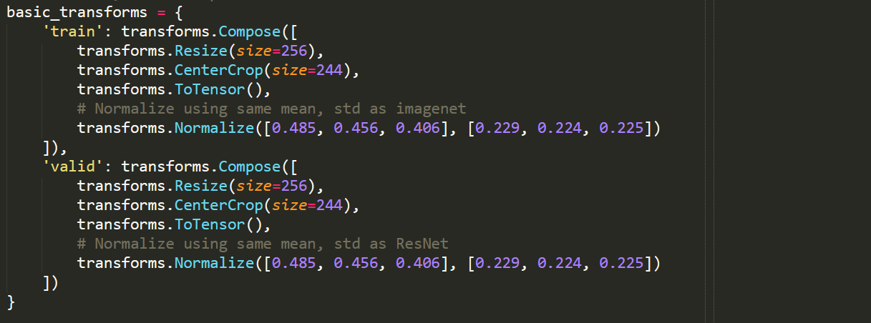

Figure 11. Basic transforms.

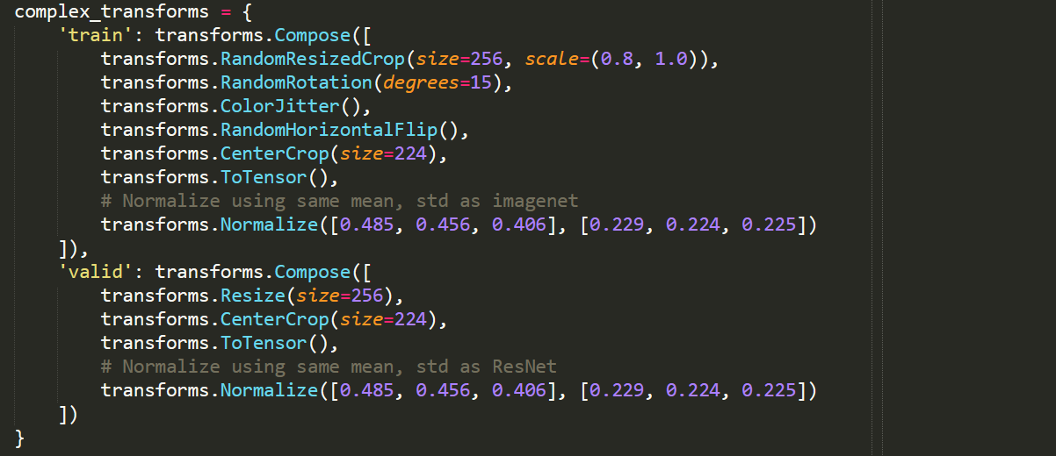

Figure 12. Complex transforms.

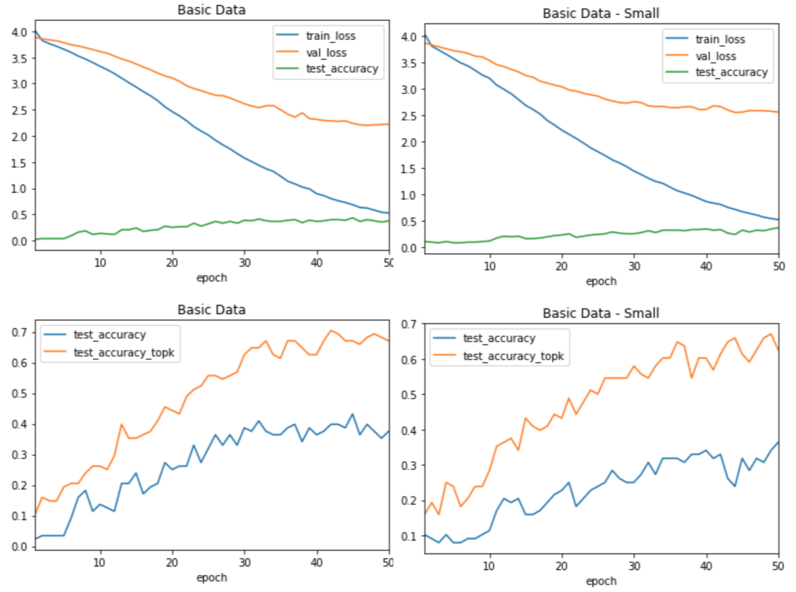

Figure 13. Basic transforms.

## 

Figure 14. Complex transforms.

## Balance

### Links

* [Notebook 6](https://github.com/leogodin217/motorcycle_classification/blob/master/code/6%20-%20Testing%20Data%20Balance.ipynb): Code to test various data balances. (Utilizes modelingfunctions.dataprocessing, modelingfunctions.modeling and modelingfunctions.utilities.)

I wanted to test how the model performs when only selecting classes with at least eight images and conversely, with fewer than eight. I found that the more images per class, the better the model performed. In one experiment, I used only 10% of the images for validation and 10% for testing. This model performed the best, but I was concerned that was too few images for validation and testing. Therefore, I decided to use only classes with at least eight images, using 20% for validation and testing. As expected, classes with fewer than eight images performed worse.

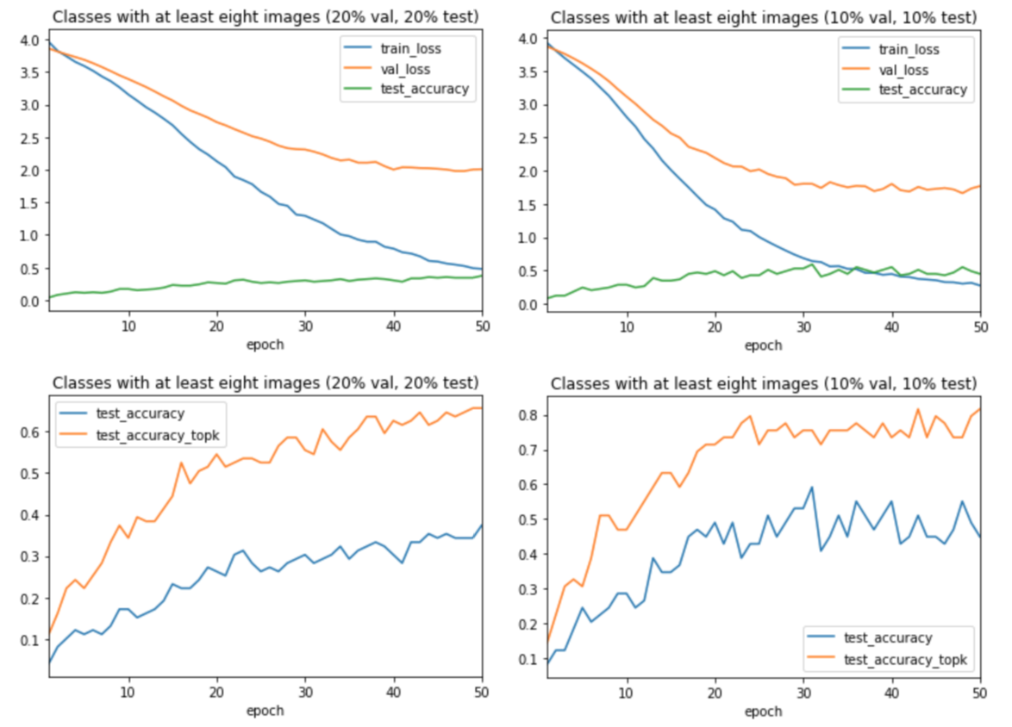

Figure 15. Classes with at least eight images.

# Modeling

Most of the experiments shown in this document utilize transfer learning through ResNet-34. This model is a popular convolutional neural network containing pre-trained weights. Early on, I created functions and code that would build and train the network. It became burdensome to copy and paste the code between notebooks, so I moved the code into a python package. All results in this document utilize code from the package.

The most interesting code from this package replaces the final fully-connected layer of ResNet with a custom layer used to classify motorcycles. Here we see a combination of linear layers and Relu functions. We also include batch normalization in the final model for generalization. We will discuss that more in a future section.

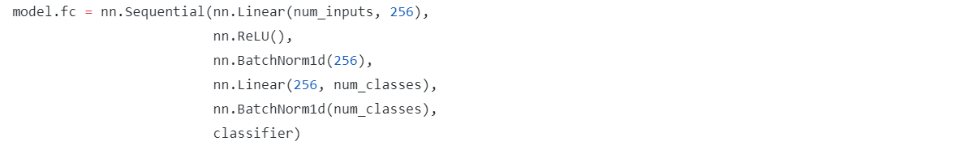

Figure . Replaced fully-connected layer in ResNet.

## Model Selection

One thing to note on all results is that they are stochastic. ResNet with random data transformations is not a deterministic model. This means we may run the exact same experiment twice and get different results. Normally, we would seed the random generator, but I chose not to. This allowed me to see how the results would vary. I tested various optimization functions and ADAM optimization greatly outperformed everything else. All results in this document use ADAM optimization.

### Resnet

### Links

* [Notebook 7](https://github.com/leogodin217/motorcycle_classification/blob/master/code/7%20-%20Model%20Selection.ipynb): Code to test various models. (Utilizes modelingfunctions.dataprocessing, modelingfunctions.modeling and modelingfunctions.utilities.)

ResNet is a complicated convolutional neural network that provides world-class results for image recognition. It comes in several flavors, each one more complicated. My testing showed the most promising results from ResNet-34. This model provided better accuracy than the less complicated models and better generalization than the more complicated models.

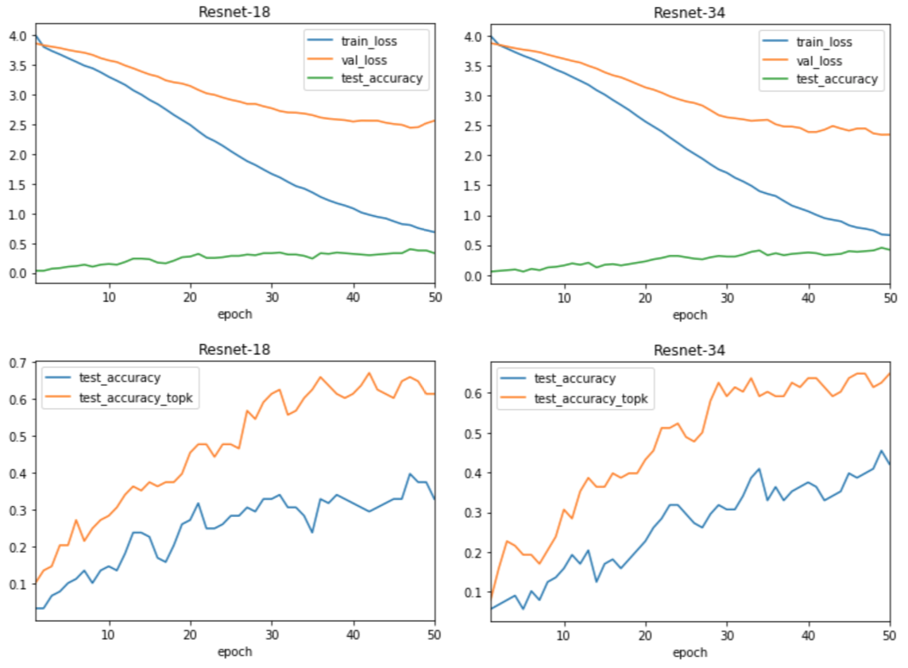

Figure 17. ResNet-18 and ResNet-34

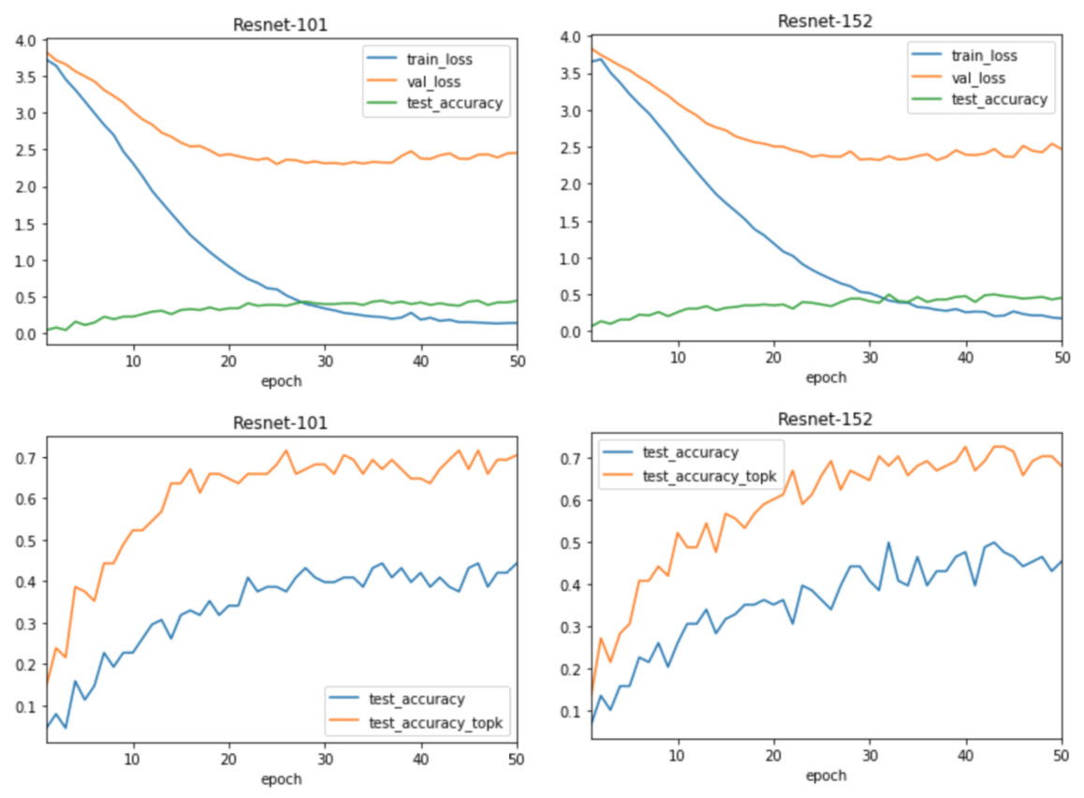

Figure 18. ResNet-101 and ResNet-152.

### Generalization

### Links

* [Notebook 8](https://github.com/leogodin217/motorcycle_classification/blob/master/code/8%20-%20Batchnorm%20vs%20Dropout.ipynb): Code to test various methods of generalization. (Utilizes modelingfunctions.dataprocessing, modelingfunctions.modeling and modelingfunctions.utilities.)

Generalization entails modifications to the model to ensure it does not only fit the training data, but validation and test data as well. There are three common methods used in convolutional neural networks, batch normalization, dropout and none. Dropout randomly ignores some proportion of the features. This provides generalization by only using a random set of features during each epoch. While this is good for generalization, it requires more epochs for training and often lowers accuracy. Batch normalization takes a different approach.

Instead of ignoring features, it normalizes the output of one layer and before passing it to the next layer. This ensures that during each epoch, the model is using the same distribution between all layers. With no generalization, we simply pass data as it is. My experiments showed that batch normalization was probably the best. Just like in other experiments, there was not a clear winner, but something that seemed to generalize better, while still having room to improve with more training. More importantly, batch normalization shows a steadily decreasing validation loss.

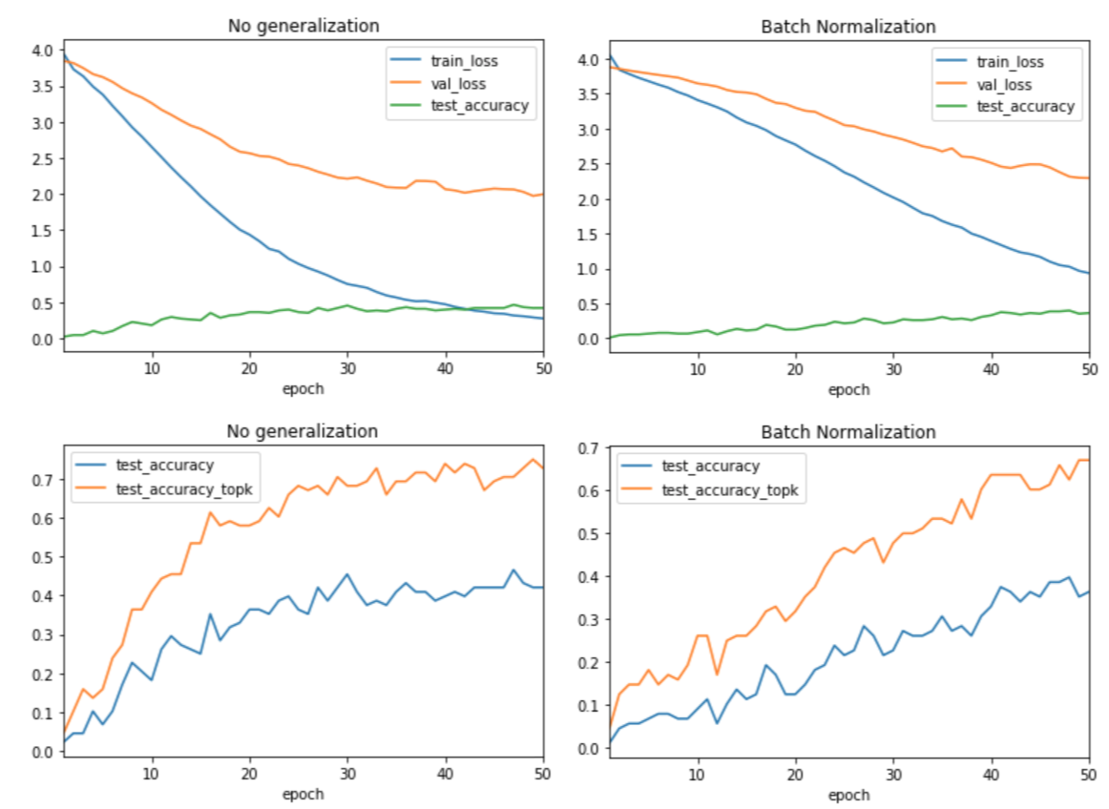

Figure . Batch normalization vs. no generalization.

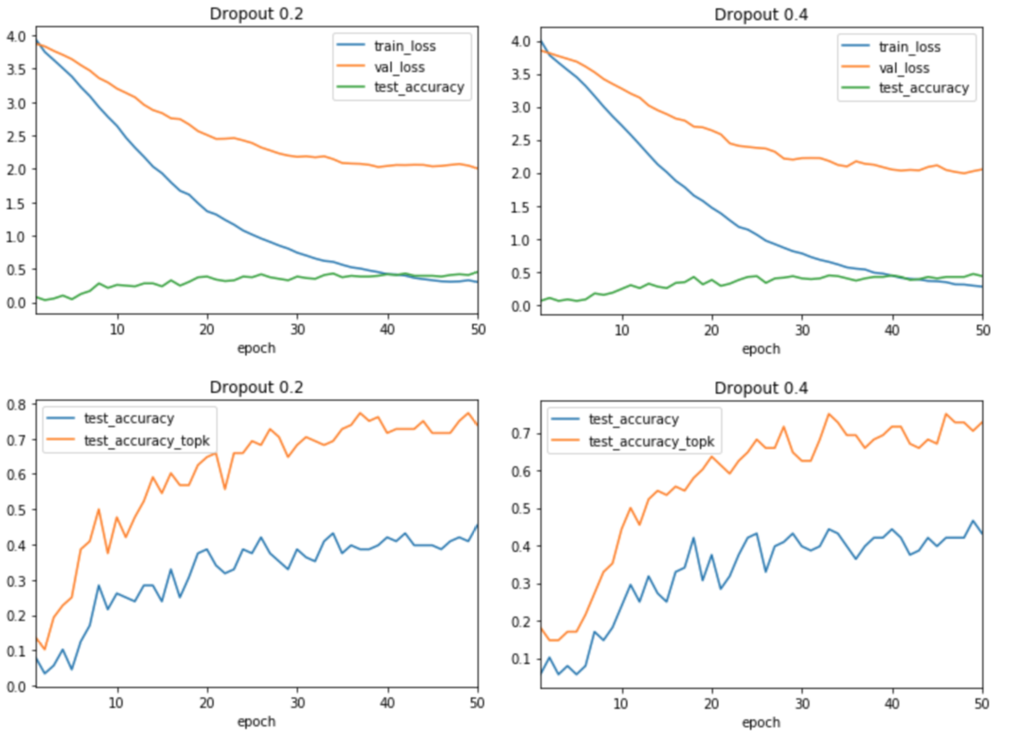

Figure . Droput 20% vs. 40%.

## Model tuning

Now we have a final model, including data transforms and normalization, we need to tune the model. There are two hyperparameters that should be tuned using ResNet-34 with ADAM optimization, learning rate and batch size.

### Learning rate

### Links

* [Notebook 9](https://github.com/leogodin217/motorcycle_classification/blob/master/code/9%20-%20Learning%20rate.ipynb): Code to test various learning rates. (Utilizes modelingfunctions.dataprocessing, modelingfunctions.modeling and modelingfunctions.utilities.)
* [Notebook 10](https://github.com/leogodin217/motorcycle_classification/blob/master/code/10%20-%20Learning-rate%20decay.ipynb): Code to test learning rate decay. (Utilizes modelingfunctions.dataprocessing, modelingfunctions.modeling and modelingfunctions.utilities.)

Learning rate is the first hyperparameter to tune. I tested rates as high as 0.003 and as low as 0.001. In general, I found that lower learning rates had less various between epochs, but the effect was not nearly as different as I expected. There is a lot of randomness from one epoch to the next.

The image below shows the difference between lr=0.001 for 100 epochs and lr=0.0005 for 200 epochs. Both have similar patterns. Though, 0.0005 has slightly smaller peaks and valleys. I also tested learning rate decay. It did not perform well. See notebook 10 for the results. Finally, I tested lr=0.003 and let it run for 200 epochs. That provided promising results. In the end, I decided to stick with lr=0.0005, as it should provide the most consistent results, considering the variance we see from epoch to epoch.

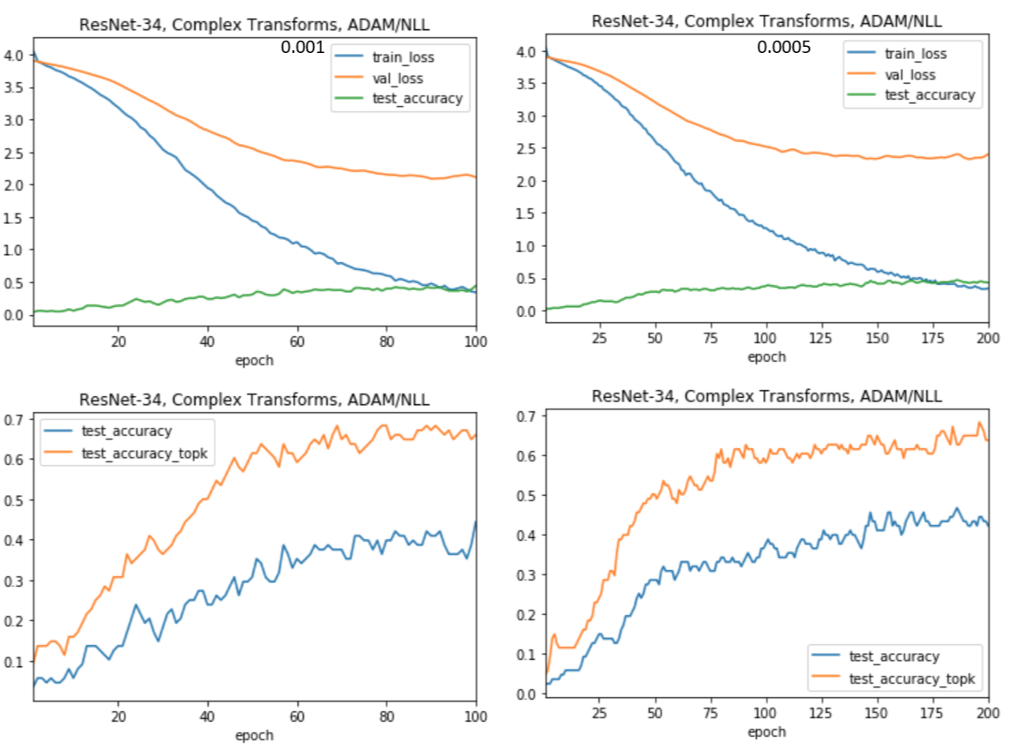

Figure . Learning rate 0.001 vs. 0.0005.

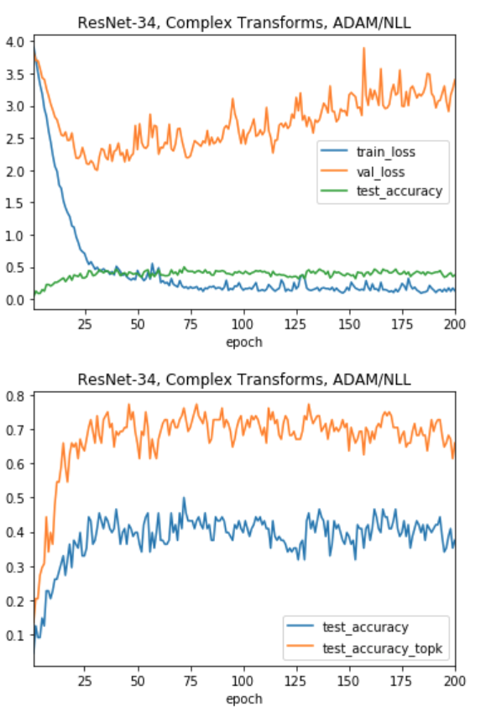

Figure . Learning rate 0.003.

### Batch Size

### Links

* Notebook 11: Code to test batch size. (Utilizes modelingfunctions.dataprocessing, modelingfunctions.modeling and modelingfunctions.utilities.)

Throughout most of this work, I assumed batch size only impacted the physical performance of the model. Larger batch sizes would take less time to train than smaller batch sizes. I found out that the ADAM optimizer changes with batch size, as the gradients are calculated after each batch. Using a batch size of 64 worked best. 128 did showed more variance after 75 epochs and 32 showed an increasing validation loss.

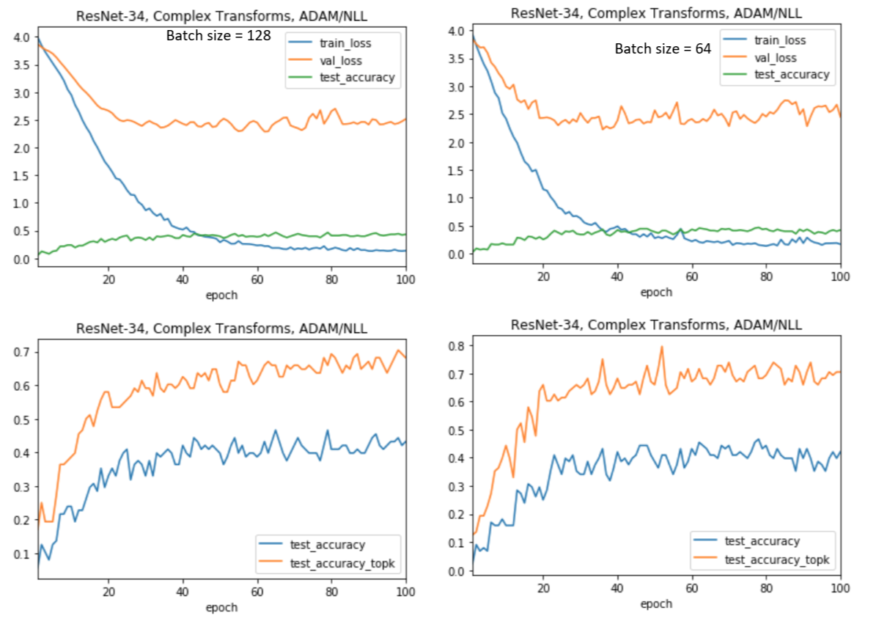

Figure . Batch size 128 vs. 64.

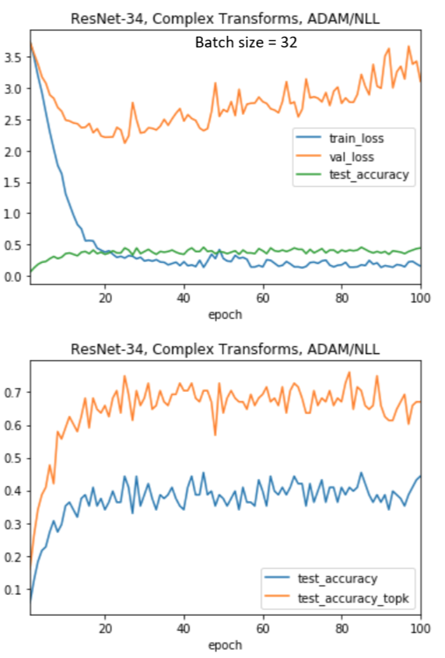

Figure . Batch size = 32.

# Final Model

Links

* [Notebook 12](https://github.com/leogodin217/motorcycle_classification/blob/master/code/12%20-%20Final%20Model.ipynb): : Code to run the final model. (Utilizes modelingfunctions.dataprocessing, modelingfunctions.modeling and modelingfunctions.utilities.)

It has been a long journey, but we are not at the point where we can see the final model. This is a ResNet-34 model, using ADAM optimization and batch normalization. We use a batch size or 64 and a learning rate of 0.0005. Towards the end of 200 epochs, it consistently hits above 40% accuracy and above 70% top-3 accuracy. This is the best results from any model shown previously. Not bad.

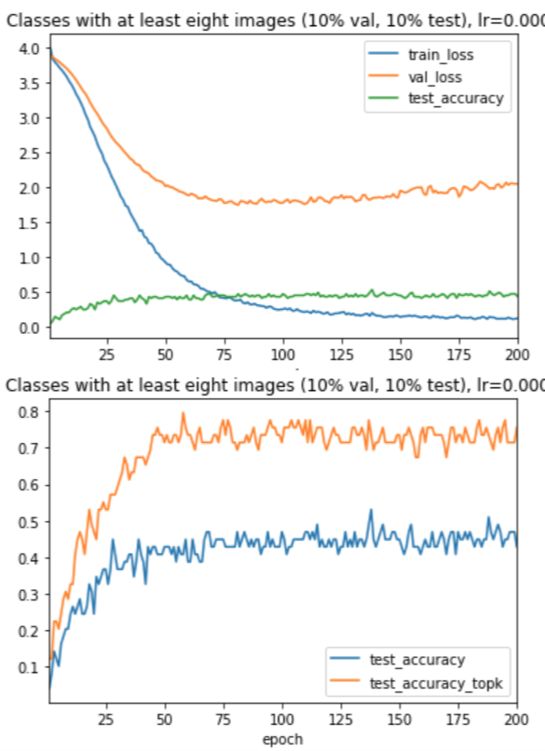

Figure . The final model.

# Further Research

I am not sure if further research is the correct term. While we found many ways to impact our results, nothing was completely consistent. Some of our sub-optimal models may provide a better result at epoch 200 than our best model. There is just too much inconsistency. To improve this model, much more data is needed. We have 366 classes and they mostly only cover motorcycles made between 2016 and 2018. A comprehensive set of classes would number in the thousands. Yet, we have proven that a convolutional neural network can be trained to classify motorcycles. A governmental or commercial application is likely plausible with more data.

# Conclusion

Our goal was to classify images of motorcycles by year, make and model. We utilized Pytorch transfer learning with a ResNet convolutional neural network. Early attempts stalled below 40% accuracy. Through data transformation, model building and model tuning, we consistently achieved above 40%, with greater than 70% top-3 accuracy.

While these results are encouraging, they would likely greatly improve with much more data. With so few images for so many classes, we needed to utilize data augmentation. This augmentation created a large variance in loss and accuracy from epoch to epoch. This created a situation where stopping at 199 epochs might increase accuracy by up to 5% over stopping at epoch 200.

This was a satisfying project. I learned a lot about convolutional neural networks and PyTorch. As a bonus, I learned about parallel programming and image manipulation in Python. Though, I will not likely continue this project, I now have the skills to tackle other challenges.